Arrays in Assembly Language

Paul Collado

Department of Computer Science

Montclair State University

CMPT280

Assembly Language

11/18/2014

Exercise 1:

1. Problem:

Create, in memory, the following 2-Integer array

Array(2) = [3]

[4]

1. Print its contents to the console
2. Solution:
3. Analysis:

I created an Array with 2 spaces then in main; I loaded the array address to $t0, then loaded 3 into $1 and after that I stored the value of $t1 into the first index of the array, I then did the same thing for a second value, then I load contents of first array index into a variable $t3 and move that into $a0 to print, I repeated the process for the second index.

1. Program code:

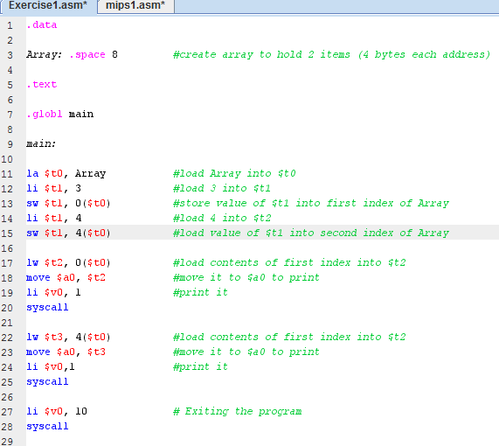

1. Example:

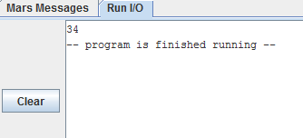

Exercise 2

1. Problem:

Create, in memory, the following 3-integer array

Array(3)=[2]

[3]

[4]

1. Add the 3 integers of the Array(3)
2. Print the result of the addition
3. Solution:
4. Analysis:

I followed almost the same process as the exercise 1, but this time I made the Array larger and I added a new value to the array, then in move the contents to three different variables and I added them, and finally I printed the result

1. Program code:

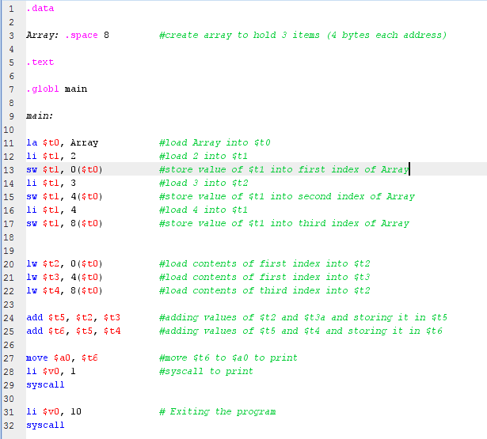

1. Example:

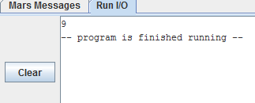

Exercise 3

1. Problem:

Create in the memory, the following two 2-integer arrays (vectors):

Array(A), Array(B).

Array(A)= [2], Array(B)=[4]

[3] [5]

1. Add the two created arrays (vectors):

Array (C) = Array(A) + Array(B)

1. Print the elements of the resulting array: Array(C)
2. Solution
3. Analysis:

I first declared 3 Arrays( A, B , C) then I load Array A into $t0, then I load the contents into the first and second index of Array A, I repeat the process for Array B, then I load the contents of both arrays into registers, I add the register and stored the results in others registers ($s4 and $s5). Then I load Array C into $t2, I store the contents of $s4 and $s5 into the Array C, finally I print the contents of Array C

1. Program code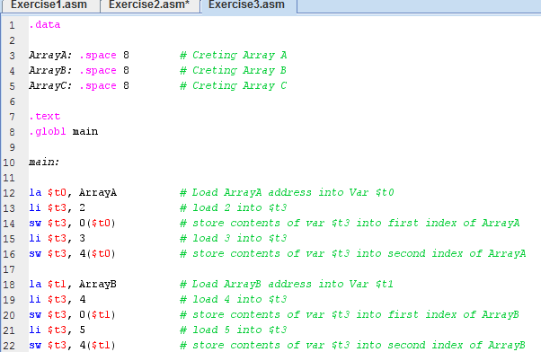

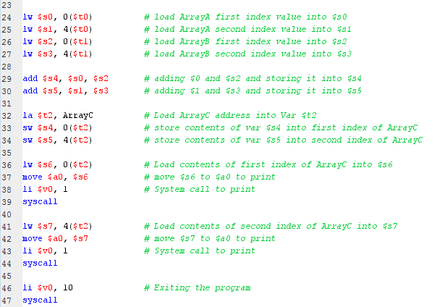

1. Example:

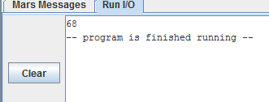

Exercise 4 (EXTRA CREDIT)

1. Problem:

Create two 2-dimensional array containing 4 integers each, and multiply them, then store the results on a third 2-dimensional array

Array A= [1, 2] X Array B = [5, 6] = Array C = [19, 22]

[3, 4] [7, 8] [43, 50]

1. Print the result of Array C